Table of Contents
Brief 2
Goals – project 3
Goals – development skills 4
Features 5
Phases 6
Architecture 7
Storage 7
Tech stack & environment 8
Sketches 9
Order cycle 9
Making available: 10
skip 11
extract to beans format 12
Cull available items 13

Brief
Eating well and living mindfully leads away from supermarkets with their long supply chains, squeezing of farmers and chasing of shareholder profits toward small groups of people cooperating to buy from trusted farmers in their area. To source organic food locally and reliably though is quite complex especially on the scale of 10 - 30 members of a typical food group. What is needed is an app which takes away much of the pain of organising custom orders of regular local ethical food.

A sophisticated and intuitive app which enables the many facets of a food group to work smoothly could also then be a major help in others wishing to adopt the local food group approach. This is not a lucrative business opportunity: there is not more than $50 per week per group for this kind of app. However for those who want the freshest most nutritious food grown in a way that builds soil and gives local farmers a fair return this app would soon become essential.

Russell & Gabrielle Austerberry have been involved in such a group for 5 years, using a local online web app. While ensuring $3000+ of custom orders per fortnight within a group of 40 people would be impossible without it, there are many places where friction could be reduced. ‘Beans’ is a re-think and extension of existing software.
The development of ‘Beans’ also is a means for Russell to learn and showcase skills in web development with a strong focus in Vue JS.

Goals – project
- An easy-to-administer management tool for food group organisers
- An easy-to-use ordering and reminder tool for food group members
- A fast, mobile, easy to use app that works well even with flaky internet
- An app which assists admin & members as follows:
  - Sophisticated import & processing of supplier availability files
  - Intuitive ordering and shopping cart experience
  - Managing orders to suppliers
  - Generated printouts for delivery, packing and pickup
  - Timely notifications re ordering, pickup, packing rosters, etc
  - In-app tracking of invoices & payments for both suppliers and members
  - API/s to allow integration with 3rd party invoicing, chat and ordering software
  - Flexible array of real-time reporting features

Goals – development skills
Demonstrate web development proficiency across the following areas.

To view commits and code in Github, let me know your username so I can invite you as collaborator on private repository.

Progress rated by stars, as at May 2020:
⚫⚪⚪ preliminary research
⚫⚫⚪ basic implementation
⚫⚫⚫ thorough implementation

- Planning (this document)
  - concept articulation & development ⚫⚫⚪
  - user stories, sketches & wireframes ⚫⚫⚪
  - data modelling ⚫⚫⚫
- Setup
  - Vue CLI ⚫⚫⚫
  - version control (Git) ⚫⚫⚪
  - Test coverage ⚫⚪⚪
  - Deploy to web ⚫⚪⚪
- Vue
  - folder structure ⚫⚫⚪
  - naming convention ⚫⚫⚪
  - modular & elegant code ⚫⚫⚪
  - well commented code ⚫⚫⚫
  - appropriate data structures ⚫⚫⚪
  - logical routing system ⚫⚫⚪
  - simple navigation system ⚫⚫⚪
  - scalable state management ⚫⚫⚪
  - fast & reactive app ⚫⚪⚪
  - mix of libraries, JS, HTML & CSS ⚫⚫⚪
- Persistent storage
  - in-app first (via PouchDB) ⚫⚪⚪
  - synced to cloud (via CloudDB) ⚫⚪⚪

Features

- Admin
  - calendar based order cycle management
  - Role based management of packing teams & others
  - Import and translate supplier lists to standard ‘beans’ format
  - Fast multi-level sorting, culling, modifying & replacement of items
  - Flexible pricing structures
  - Print-ready exports of various lists (delivery checklist, member orders, packing sheets)
  - API for interaction with other ordering systems
- Finance
  - Auto invoicing with tracking for member & supplier balances
  - Real time reports: sales|surcharge|member-history per order cycle|quarter|year
  - API for integration with accounting package (Xero etc)
- Members
  - Easy online ordering
  - Reminders & notifications (to order, buy extras, news, call for packers)
  - ‘Demo mode’ when outside ordering window
  - Customisable recurring orders
  - invoice, payment & balance history on demand
- General
  - authentication & role-based permissions for access to ordering/admin/finance functionality
  - onboarding and setup wizards

Phases
Progress as at May 2020 marked by 1 to 3 stars.

Preliminaries: ⚫⚫⚫
Planning
Architecture
Tech stack
Version Control
Initial setup of project
Basic folder structure
Navigation model
Routing model

Scaffolding:
Look and feel ⚫⚫⚪
State management pattern ⚫⚫⚪
Persistent storage patterns ⚪⚪⚪
Component development: Making Available ⚫⚪⚪

Development:
Admin ⚪⚪⚪
calendar
calendar-based order cycle
main admin interface
Authentication
authentication system with roles & permissions
notification system – based on calendar, roles, permissions
Ordering
shopping cart for members
order → invoice tracking + member balances
ordering management via suppliers
Accounting
track all transactions
export to csv
APIs
notification API for integration with Slack or similar
availability API for suppliers to list items
API for integration with Xero etc

Production: ⚪⚪⚪
Testing & Deployment
set up testing framework
set up hosted solution
deploy
Maintenance

Architecture

Storage
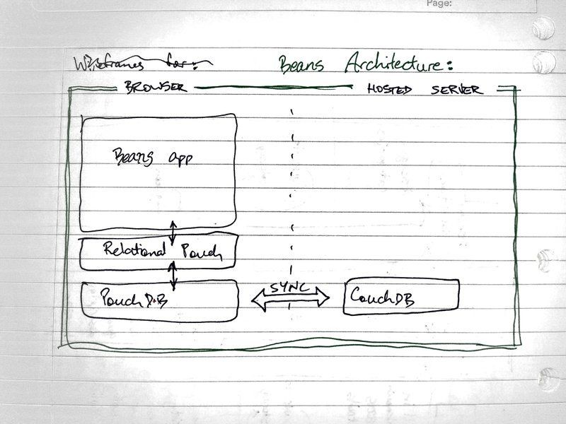
Note during development the decision has been made to steer away from ‘relational’ and store data via JSON schema. See ‘schema.txt’ within ‘beans’ working directory to see what that looks like.

PouchDB is designed to store data in the browser, and to sync with CouchDB over the wire for ‘eventual consistency’. This ‘browser first’ architecture means that once the app is loaded it can run without further connection to the web, but will also sync to a ‘dumb’ database when connection is available. The aim is to make the app accessible in a paddock or a packing venue even if there is questionable connectivity.

Tech stack & environment
It’s Vue through and through.
- Vue, vue-router, vue-unstated & numerous other Vue libraries
- HTML, CSS, JavaScript are integrated, focussing on Bulma CSS framework
- PouchDB – for browser persistence
- CouchDB – for offline persistence
- hosting environment to be determined
- Development on Ubuntu box, synced to laptop
- Visual Studio Code IDE
- Github repository

Sketches

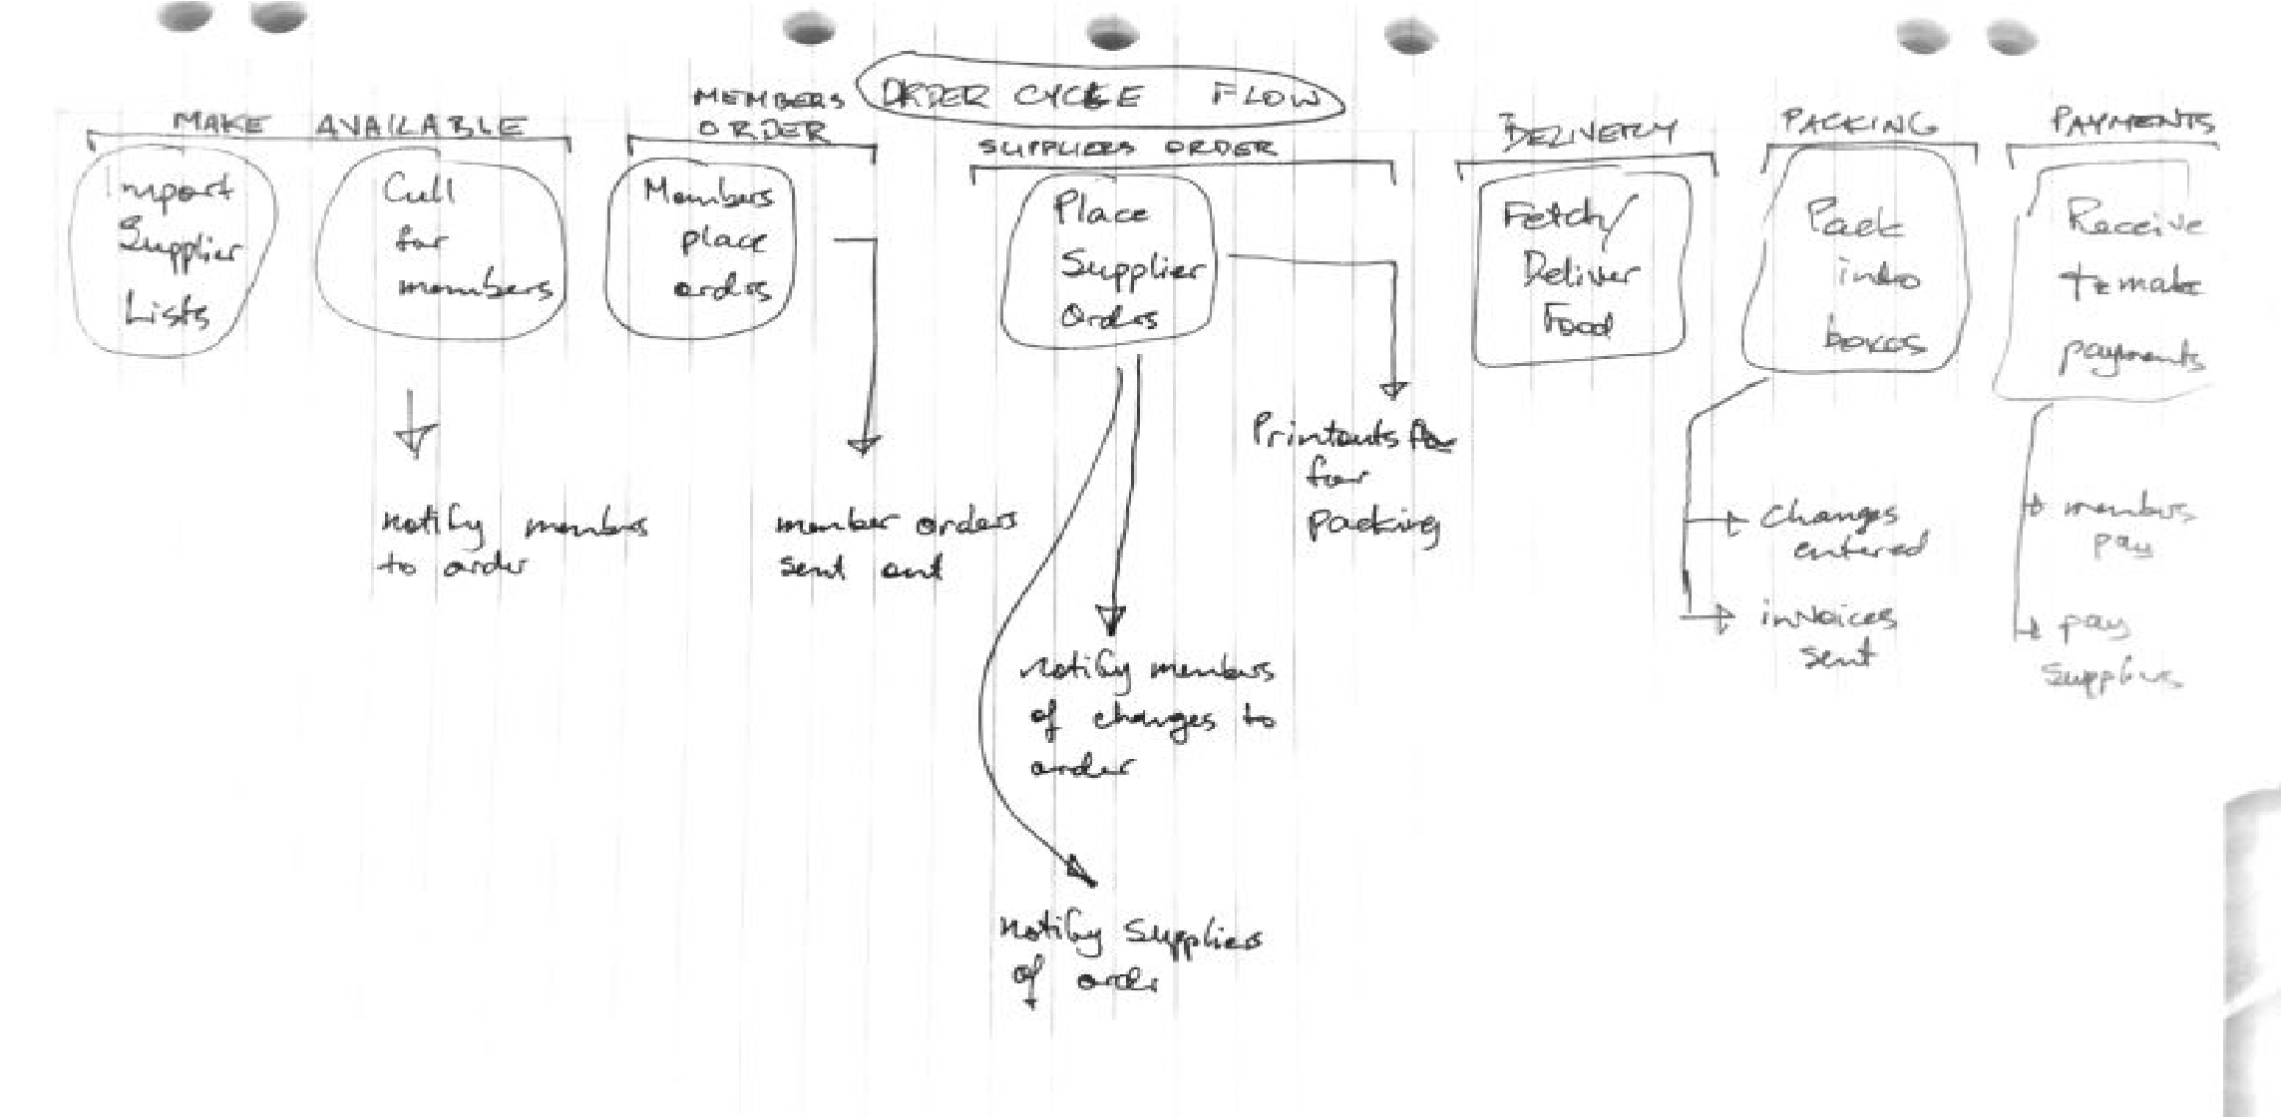
Order cycle

Making available:
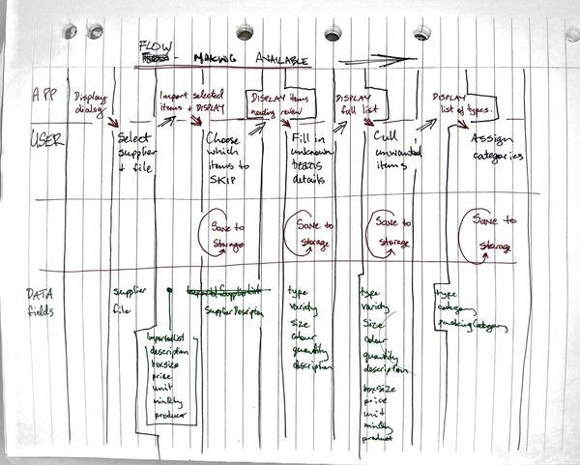
This shows the most complex path ie importing & translating a supplier’s availability list.
The simpler (more tedious) path is manually updating product availability per supplier.

skip
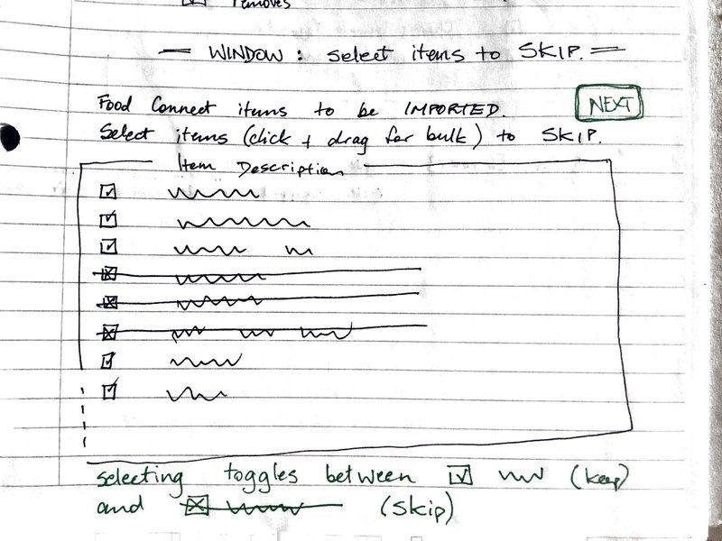

extract to beans format
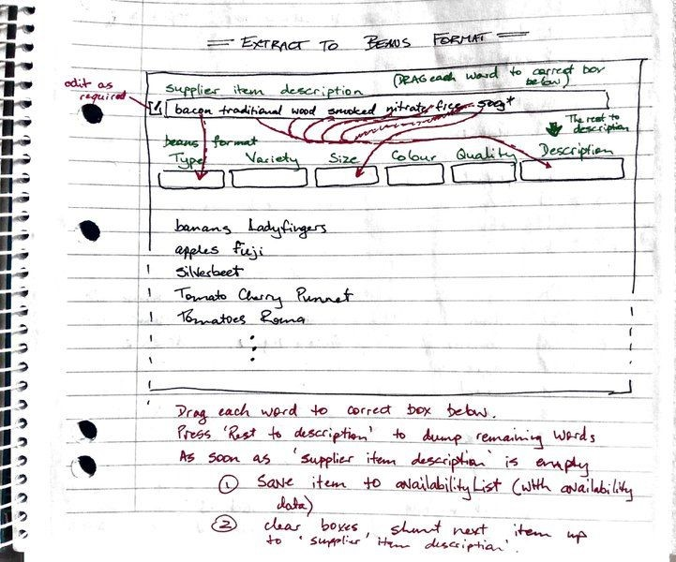
Once imported, process each line into ‘beans’ format – automatically if possible, with user input otherwise. (This step enables advanced searching and sorting later on).

Cull available items
